**Introduction to Ribbon Finance**

​[Ribbon Finance](https://app.ribbon.finance/) is a suite of DeFi protocols that help users access crypto structured products. By combining derivatives, lending and a proprietary [on-chain options exchange (Aevo)](https://docs.ribbon.finance/aevo), Ribbon aims to be the one-stop solution for users who want to improve a portfolio's risk-return profile.

Here you can find the products descriptions and [outgoing links](https://docs.ribbon.finance/communication-channels) to the different communication channels, where you can reach out to the Team and Community.

**Theta Vaults (DOVs)**

Theta Vaults, also known as DOVs (DeFi Options Vaults), were invented by Ribbon in 2021. At its core, a Theta vault is a yield-oriented strategy that proposes that depositors trade volatility on their underlying by selling [European options](https://www.investopedia.com/terms/e/europeanoption.asp) with weekly expiration. The sale value of these options, or "premium," is set through [auctions](https://docs.ribbon.finance/theta-vault/theta-vault#auctions) and determines the vault return. The vault reinvests the premiums earned back into the strategy, effectively compounding them for depositors over time.

There are two types currently active:

1. 1.

​[Covered call selling](https://www.investopedia.com/terms/c/coveredcall.asp): each week the vault issues [OTM (out of the money)](https://www.investopedia.com/terms/o/outofthemoney.asp) call options on all deposits.

1. 2.

​[Put selling](https://www.investopedia.com/terms/p/putoption.asp): each week the vault issues OTM put options on all deposits.

For more information you can check [this section](https://docs.ribbon.finance/theta-vault/theta-vault).

**Ribbon Earn**

The [R-Earn vaults](https://docs.ribbon.finance/ribbon-earn/introduction-to-ribbon-earn) employ fully funded strategies to capitalize on the intra-week ETH movements, while also ensuring their capital is protected. The vaults earns a base APY and uses the remaining funding to purchase weekly options.

There are currently two vaults available:

1. 1.

Earn USDC: it employs a twin win strategy through which depositors can capitalise on the intra-week ETH movements in either direction;

1. 2.

Earn stETH: employs dolphin strategy through which depositors can capitalise on the upside ETH movements.

For more information you can check [this section](https://docs.ribbon.finance/ribbon-earn/introduction-to-ribbon-earn).

**Ribbon Treasury**

Ribbon Treasury are private Ribbon Theta vaults built specifically for DAOs to run covered calls（虚值看涨期权） on their native tokens. These private vaults are segregated from the main Ribbon vaults, and run a custom strategy for each DAO. Each vault has a few unique parameters:

* **Strike Selection Methodology** DAOs can choose how aggressive they want to be with regards to the strike selection methodology.
* **Tenor** DAOs can choose how often they want to run the strategy. The current Ribbon Vaults run a weekly strategy that automatically re-rolls, but DAOs can choose longer tenors.
* **Premium Currency** DAOs can also choose what currency they want to receive the premiums in. For example, a DAO could elect to receive premiums in USDC or ETH, depending on their treasury diversification goals.

For more information you can check [this section](https://docs.ribbon.finance/ribbon-treasury).

**Ribbon Lend**

Ribbon Lend can be described as an uncollateralized Aave, allowing depositors to lend unsecured to KYC/AML’d institutional market makers of their choosing with high liquidity. Ribbon Lend offers the best of both worlds between TradFi and DeFi:

* High yields from unsecured lending
* No lockups from Aave’s money market model
* Off-chain enforcement / credit underwriting
* Built-in insurance

For more information you can check [this section](https://docs.ribbon.finance/ribbon-lend/introduction-to-ribbon-lend).

# Aevo

​[Aevo](https://www.aevo.xyz/) is a high-performance, order-book based decentralized exchange that comes with all the features necessary for a pro options trader（专业期权交易员）. This includes a robust margining system (with portfolio margin（组合保证金）), as well as hundreds of instruments to trade, including daily/weekly/monthly/quarterly options. All of this is built on a custom EVM rollup that was designed for scale, and rolls up to Ethereum for security.

Aevo aims to become the #1 venue to trade options on-chain. The 3 main advantages that Aevo brings users are:

* 100+ instruments, with many strikes and expiries
* Deep liquidity, by partnering with the best options trading firms in the world
* Instant onboarding, deposit USDC from any EVM-chain

### Aevo is currently in closed beta! For more info, follow the official [Aevo account on Twitter](https://twitter.com/aevoxyz?s=20&t=JZxnjejSmSBJVJbF1fxTxA), check out this [blog post](https://mirror.xyz/aevo.eth/XtueK0oiRozH7mNVwBdpHLNlSf9vXEV6Nsa6ivWAYfo) and the [FAQs](https://docs.ribbon.finance/faq/aevo)​

FAQ

# Aevo

### What kind of relationship will there be between Ribbon and Aevo? Will Aevo be a part of Ribbon or will it be autonomous? If it will be autonomous, will it have its own governance token? Wen token?

Aevo is part of the Ribbon family of products. The Ribbon team is working on both products (structured products & options exchange). At launch, the exchange will run without any token-related economics until it achieves meaningful scale.

Eventually, Aevo will be integrated with Ribbon as the venue where Ribbon’s options contracts settle. This means that Ribbon Vaults can drive consistent flow to Aevo (currently ~$80m a week), and Aevo can allow for much more sophisticated vault structures to be built on top — a perfect harmony of vault + exchange.

### If I am a vault depositor do I get any advantages by using Aevo (e.g. can I edge my positions)?

Yes, users can hedge their vault positions by buying options on Aevo. But there are more potential developments! For example, Ribbon users’ funds may no longer need to be locked up from a week-to-week basis. They can exit their vault position anytime by simply closing the position on the exchange. Users will also be able to take profit on or cut losses on their vault positions, since there will be a venue with high liquidity to trade these positions.

### If I am an Auction participant, do I have any advantages by using Aevo?

Ribbon Auction participants will benefit greatly from this integration. Instead of sitting on oTokens in their wallet until expiry, market makers can use these vault positions as real positions on an exchange — giving them margin to trade more things, take profit, hedge, and so on. We think this will attract much more interest in the Ribbon Auctions and will make pricing more competitive.

# General

### What are structured products?

​[Structured products](https://www.investopedia.com/articles/optioninvestor/07/structured_products.asp) are packaged financial instruments that use a combination of derivatives to achieve some specific risk-return objective, such as betting on volatility, enhancing yields or principal protection（本金保护）.

### What is the risk of the covered-call vault?

The primary risk for running a covered-call strategy is that depositors could potentially give up upside in exchange for guaranteed yield. By selling a call option users are essentially promising to sell the asset at the strike price even if the price rises. This may result in a negative yield on the underlying asset. However, in that case depositors will still be up in USD terms, as the underlying asset would have appreciated significantly in a short period of time.

### What is the risk of the put-selling vault?

The primary risk for running a put-selling strategy is that the vault may incur a weekly loss in the case where the put options sold by the vault expire in-the-money (meaning the price of the underlying asset is below the strike price of the put options minted by the vault).

### What is the options infrastructure used by the vaults?

Ribbon options are built on the Opyn V2 protocol, even on Avax.

### Is Ribbon multichain?

We're currently on Ethereum mainnet, Avalanche, and Solana. There are currently no plans to expand to further chains.

### Does Ribbon have a token?

Yes, Ribbon has a governance token, RBN. Please read the RBN announcement blog [post](https://ribbonfinance.medium.com/decentralizing-ribbon-governance-395950da7a6) for more details. The RBN token is [0x6123B0049F904d730dB3C36a31167D9d4121fA6B](https://etherscan.io/address/0x6123b0049f904d730db3c36a31167d9d4121fa6b).

### Where's the Treasury?

​[Here's the address](https://etherscan.io/address/0xDAEada3d210D2f45874724BeEa03C7d4BBD41674). The Treasury is managed by a multisig made by the Team with two members of the core community.

### Is Ribbon audited?

We're audited by [OpenZeppelin](https://blog.openzeppelin.com/ribbon-finance-audit/), [ChainSafe](https://github.com/ribbon-finance/audit/blob/master/reports/RibbonThetaVault%20V2%20Smart%20Contract%20Review%20And%20Verification.pdf) and [Peckshield](https://github.com/ribbon-finance/audit/blob/master/reports/PeckShield-Audit-Report-Ribbon-v1.0.pdf). Despite that, users are advised to exercise caution and only risk funds they can afford to lose.

### Do you have a bounty program?

Yes, we offer a bounty for up to $250,000. Learn more [here](https://immunefi.com/bounty/ribbon/).

# DOV Deposits

### Where can I find assistance on deposits?

​[Right here!](https://docs.ribbon.finance/theta-vault/user-guides/how-to-deposit)​

### What is the minimum deposit for vaults?

There are no minimum deposits to participate in our vaults.

### Will I receive vault tokens when I deposit?

Not immediately; you'll have to wait for the following Friday for the vault to use your deposited funds. In the meantime they will remain queued and NOT invested. And even after that, you will NOT receive vault tokens by default. You'll be able to get them in two different ways:

1. 1.

manually claim them by calling maxRedeem on Etherscan, and then transfer the tokens to your wallet. Please refer to our guide [here](https://docs.ribbon.finance/theta-vault/user-guides/how-to-transfer-vault-positions).

1. 2.

stake your vault position (for the eligible vaults) for RBN rewards. Please refer to our guide [here](https://docs.ribbon.finance/theta-vault/user-guides/how-to-stake-unstake-vault-shares-and-claim-rewards).

### Do I have to confirm and redo my deposits every week?

No, the vaults re-invest your deposits on a rolling basis.

### Are deposits subjected to profit or loss from the previous week

No, if you deposit mid-week, you are not exposed to the vault's performance from the previous week.

### Do you recover deposits accidentally made to an incorrect receiving address?

Although we do not generally offer token recovery services, we review these instances on a case by case basis depending on their significance. We do not guarantee token recovery and advise depositors to double check their transactions.

# DOV Withdrawals

### Where can I find assistance on withdrawals?

​[Right here!](https://docs.ribbon.finance/theta-vault/user-guides/how-to-withdraw)​

### Are queued withdrawals subject to profit or loss of the week?

Yes, since you are initiating a withdrawal for vault shares, those shares are subject to either the profits or losses of that week, which will adjust the final withdrawable amount.

### Can I cancel a queued withdrawal?

Unfortunately, you can't cancel a queued withdrawal. You'll have to complete it and reinvest the funds at a later time. [Remember that you can also pause your position](https://docs.ribbon.finance/theta-vault/user-guides/how-to-pause-and-resume) instead of withdraw.

### Do planned/queued withdrawals count as two gas transactions?

Yes, this process will count as two gas transactions.

### Can I withdraw stETH from the T-STETH-C vault?

You can ONLY withdraw stETH from the T-STETH-C vault.

# DOV Trading and options

### What is the fee structure?

The vault fee structure consists of a 2% annualized management fee and a 10% performance fee. If the weekly strategy is profitable, the weekly performance fee is charged on the premiums earned and the weekly management fee is charged on the assets managed by the vault. If the weekly strategy is unprofitable, there are no fees charged.

### How is APY calculated?

We calculate APY by getting the average of the past 4 week's annualized performance:

Weekly Yield = ((1+(Curr. Week’s Performance)^52)-1)*100

Projected Yield (APY) = Average of Past 4 Week's Weekly Yield (in the money weeks are excluded)

### Are the management and performance fees included in the expected APY?

Yes.

### Where can I see the historical performance?

Every product has a card with the vault's graphical representation of historical performance. You may refer [here](https://www.tokenterminal.com/terminal/projects/ribbon-finance) for further insights.

### Are the management and performance fees included in the previous week's performance?

Yes.

### What asset are the vault yields paid in?

Yields are paid in the same underlying deposit asset. The only exception are the staked tokens vaults: stETH, rETH and sAvax. You can deposit either vanilla ETH/Avax or the staked versions but you'll be able to withdraw stETH, rETH and sAvax only.

### Are the vaults cash or physically settled(现金结算还是实物结算)?

Our vaults are [cash settled](https://www.investopedia.com/terms/c/cash-settled-options.asp), which means you do not need physically deliver an asset on expiry. Call options are cash-settled with the collateral asset, whereas put options are cash-settled with USDC.

### Do vaults use a delta neutral strategy?

No.

### How is the strike calculated?

Our V2 vaults use an algorithmic strike selection with a delta of 0.1 for writing options, see our blog post [here](https://ribbonfinance.medium.com/algorithmic-strike-selection-e07ae917c146) and the underlying Black-Scholes model [here](https://github.com/ribbon-finance/rvol/blob/master/contracts/core/OptionsPremiumPricerInStables.sol#L163). The process is currently managed offchain, because it would be very gas intensive and impractical.

### How can I find out the next strike in advance?

There is no way to know the strike in advance as it's calculated using last minute data feeds. For now, you can make an educated guess looking at 10d on Deribit.

### How is the IV calculated/sourced?

The model for IV isn't open but based on IV at 10d and adjusted with historical volatility. We use the 10d IV from Deribit for ETH/BTC and roll our own algo for alts.

### Where can I learn more about the strategies?

Please refer to the vault cards on our website as they have a step-by-step guide to the strategy currently used.

### Can I buy the options written by the vaults?

Yes, if you'd like to participate in our auctions, please join our Telegram [channel](https://t.me/+vzLH75fnssMxMGI1) - and access our new auctions [website](https://auction.ribbon.finance/). For more information please refer to the guide [here](https://docs.ribbon.finance/theta-vault/user-guides/how-to-participate-in-paradigm-auctions).

### I've bought some options and they are expiring ITM, do I need to do something to exercise?

There is no further action needed on your end as we are using Opyn V2, options self exercise when needed. You just need to claim them at any time.

### How can I redeem my assets if the options expire in the money?

Please refer to the Opyn V2 interface [here](https://gammaportal.xyz/#/account/). Also, here's a [practical guide](https://docs.ribbon.finance/theta-vault/user-guides/how-to-redeem-otokens).

### ****Is there a deadline for exercising oTokens?****

The profits from exercising the options are locked in on expiry. There is no deadline for exercising oTokens.

### ****The options expired in-the-money. Why can't I claim the collateral?****

After the options expire at 8am UTC, there is about 1 hour dispute period for settlement. You can only claim the collateral with oTokens after 9/10 am UTC.

### I've called the max redeem but I didn't get any token. Why?

If you called max redeem the same week you deposited, you wouldn't receive any tokens as your funds weren't used by the vaults.

### Are vault tokens are 1:1 with the underlying?

No, rETH-THETA is constantly changing as premiums are collected each week. So rETH-THETA is not 1:1 to ETH.

### I just deposited in a vault, why can't I stake any rTokens?

You'll have to wait until the next Friday to stake your rTokens because your funds aren't actively used right now.

# Ribbonomics

### Can I stake my RBN（治理代币）?

YES but NO, it's not staking, it's locking so be sure to understand the differences taking a look at [this guide](https://docs.ribbon.finance/ribbonomics/how-to-lock-rbn-boost-and-claim-protocol-revenues). Locking your RBN will also give you a percentage of protocol revenues（协议收入）, paid weekly in ETH. You can proceed to lock your RBN on the Governance portal: <https://vote.ribbon.finance/>​

### Where can I see any details on veRBN in circulation, holders, average lock duration?

Here's a Dune dashboard made by our fellow Ribbonato Lewi: <https://dune.com/lewi/VeRBN-Ribbon-Finance>​

### Where can I learn more about the Ribbonomics?

Please refer to our documents [here](https://docs.ribbon.finance/ribbonomics/overview-and-rbn-tokenomics).

### I've staked the vault tokens, when can I claim my RBN rewards?

Although you can claim whenever you like, please note that you'll accumulate at every block but rewards are restocked weekly. For more information, take a look [here](https://docs.ribbon.finance/theta-vault/user-guides/how-to-stake-unstake-vault-shares-and-claim-rewards).

### Do I need to stake the vault tokens every week?

No, you just need to stake them once.

### When staking vault tokens, do I still receive the APY from the vaults or the pool rewards only?

You receive both APY from the vaults and pool rewards.

### Do I have to lock my RBN for 2 years?

No, 2 years is the maximum lock up duration. For more info, take a look [here](https://docs.ribbon.finance/ribbonomics/how-to-lock-rbn-boost-and-claim-protocol-revenues).

### Can I lock some of my RBN for different durations?

In order to lock your RBN for various durations you'll have to split them between wallets. Be mindful of your vault position(s), as you will likely lose the boost. Please, check our [guide](https://docs.ribbon.finance/ribbonomics/how-to-lock-rbn-boost-and-claim-protocol-revenues).

### How often does my boost records voting power changes?

Your voting weight decreases over time but your boost will take notice of your decreasing voting power at certain checkpoints like withdrawing or staking. For example if you start at 1000 veRBN and your voting power decreases to 800 veRBN, your boost will still use your original voting power of 1000 veRBN until a user checkpoint.

### How can I apply my boost?

After creating or adding to your lock, you need to click the "Apply Boost" button on each gauge you're providing liquidity in to apply the boost. Your boost can also be updated by depositing and withdrawing from a gauge as well as claiming RBN.

### If I boost locking RBN but I have more than one vault position, which one takes the boost?

All of your vault positions will get boosted. Please, check our [guide](https://docs.ribbon.finance/ribbonomics/how-to-lock-rbn-boost-and-claim-protocol-revenues).

### If I lock RBN for X time and then decide to extend the lock up, will I be able to do so?

Yes, you can extend the lock up period. Please, check our [guide](https://docs.ribbon.finance/ribbonomics/how-to-lock-rbn-boost-and-claim-protocol-revenues).

**Introduction to Theta Vaults**

**What are Theta Vaults?**

Theta Vaults run an automated European options selling strategy, which earns yield on a weekly basis through writing out of the money options and collecting the premiums. We use the Vault terminology because it stems from the idea of depositing your assets into a vault and earning a yield on them.

Users can simply deposit and the vaults will automatically start running a specific option strategy. This alleviates a majority of the gas problems by socializing the gas costs across all the vault depositors: instead of doing 3–4 transactions per week per user, the vault will do 3–4 transactions per week for thousands of users at once. This makes the user experience of using these Theta Vaults extremely straightforward and relatively cheap.

Theta Vaults also allow you to choose when to participate or not to participate in the weekly strategy through a [pause and resume](https://docs.ribbon.finance/theta-vault/user-guides/how-to-pause-and-resume) function, so that you do not limit your usage options in relation to your market expectations.

There are two vault types currently active:

1. 1.

​[Covered call selling](https://www.investopedia.com/terms/c/coveredcall.asp): each week the vault issues [OTM (out of the money)](https://www.investopedia.com/terms/o/outofthemoney.asp) call options on all deposits.

1. 2.

​[Put selling](https://www.investopedia.com/terms/p/putoption.asp): each week the vault issues OTM put options on all deposits.

**Strike Selection and Expiry**

Strikes are selected by an [algorithm](https://github.com/ribbon-finance/rvol) at the last minute before the corresponding option auction. The pricing parameter is fixed and is 10 [delta](https://www.investopedia.com/terms/d/delta.asp), so there is no direct relationship between the spot price of collateral and the strike; the key element is volatility.

The strike calculation algorithm is based on the [Black&Scholes model](https://www.investopedia.com/terms/b/blackscholes.asp), with appropriate adjustments. [Historical volatility](https://www.investopedia.com/terms/h/historicalvolatility.asp) is derived from Uniswap while [implied volatility](https://www.investopedia.com/terms/i/iv.asp) is determined by a proprietary closed source algorithm; it uses the 10 delta IV from Deribit for ETH/BTC while for alts there's a custom algorithm to set it. The whole model, although developed for onchain use, is executed offchain both because it is gas intensive and because it is of impractical use due to potential rounding errors and the auctions timeframe.

To further reduce the risk of the options getting exercised, Theta vaults sell *weekly* call options, meaning we can adjust our expectation of ETH’s price on a weekly basis. This also has the positive side effect of letting us compound our premiums more frequently.

**Options Architecture**

Theta Vaults in its present design relies on [Opyn](https://opyn.co/) oTokens. oTokens are ERC20 token representations of an options contract, where each of them have a strike price and expiry. Owning oTokens is functionally equivalent to owning an options contract. This gives the oToken holder the right to redeem some amount of the underlying asset if the strike price is hit.

In order to run an options-writing strategy, the Vault needs to be able to mint and short oTokens. The Vault uses the users’ deposited funds to lock collateral into Opyn + mint oTokens, then sells them for a premium. The Vault’s collateral will be locked until the expiry of the oToken. This collateral is used to pay off oToken holders in the case that the options expire in the money.

Opyn options are [cash settled](https://www.investopedia.com/terms/c/cash-settled-options.asp), so if the options expire ITM, there is no transfer of the underlying: the difference between the strike and the market price at expiry will be compensated by liquidating part of the deposits.

Also, Opyn options self exercise at expiry if ITM. In these docs you'll find more details about [settlement](https://docs.ribbon.finance/theta-vault/theta-vault/options-settlement) and [redeeming](https://docs.ribbon.finance/theta-vault/user-guides/how-to-redeem-otokens).

# Options Settlement

## Settlement price

Currently, we are relying on Opyn's infrastructure for option settlement. Opyn uses Chainlink's spot prices as a data source to settle options.

After a few improvements and learnings, we have decided to use [Pyth's](https://pyth.network/) oracle for settlement price when options expire in-the-money. The reasons as follows:

* Chainlink's data source is not designed to be used for expiries because it uses data sources such as aggregators (CoinGecko or CoinMarketCap) which are often delayed.
* Pyth provides a more accurate view of the price data due to how it fetches real-time price data from exchanges.

## wstETH and rETH options

Ribbon's vaults writes options that are collateralized with liquid staking derivative tokens such as wstETH (Wrapped Staked ETH) and rETH (Rocket Pool ETH).

There are some core differences for how settlement price is calculated for these options. How the settlement price（结算价格） is calculated is as below:

1. 1.

We figure out how much stETH each wstETH can be unwrapped for.

1. 2.

We treat 1 stETH as 1 ETH from a price perspective.

1. 3.

We set the expiry price to the price of ETH.

#### Example

We have an ETH $2000 call option. For this example, we will be collateralizing the call option with wstETH and we assume that 1 wstETH = 1 stETH. If ETH ends up in-the-money at $2500, an option holder would be able to claim $500 worth of ETH for a normal ETH call option, or 0.2 ETH.

In the case of wstETH, 0.2 wstETH can be claimed at expiry. However, 0.2 wstETH can only be traded for 0.19 ETH on liquidity pools like Curve, which means the option holder would have 5% less profits if they swapped back to ETH after claiming.

The implications for this are:

* wstETH options have the same payoff calculation as a regular ETH option, except the collateral received is wstETH, which is unwrapped for stETH.
* This means if stETH is trading 5% below the value of ETH, the amount returned from exercising the option is 5% less.

**Auctions**

After an initial period of public auctions on Gnosis, we have partnered with [Paradigm](https://www.paradigm.co/) to bring the auctions to their platform and achieve more favorable execution for vault depositors. If you want to participate, take a look at [this section](https://docs.ribbon.finance/theta-vault/user-guides/how-to-participate-in-paradigm-auctions).

Among the main reasons for the change is a structural limitation of Gnosis: it clears at the *lowest* possible price where demand meets supply. This means that if A is willing to buy half the supply for $10, and B is willing to buy the other half at $9, the entire auction will clear at $9.

Using the Paradigm system, we are able to run [blind auctions](https://en.wikipedia.org/wiki/First-price_sealed-bid_auction), in all-or-nothing format. This helps to create more price competition between bidders and reduce gaming of the on-chain auction system, ultimately leading to better pricing.

For an in-depth analysis of the auctions, you can check this [Ribbon Research post](https://www.research.ribbon.finance/blog/ribbon-auction-performance-analysis).

As a fee structure, 4bps of the notional volume done by Ribbon go to Paradigm.

**Risk profile**

The primary risk for running the covered call strategy and put selling is that the vault may incur a weekly loss in the case where the call options sold by the vault expire in-the-money (meaning the price of collateral is above -calls- or below -puts- the strike price of the call options minted by the vault).

**Fees**

The vault fee structure consists of a 2% annualised management fee and a 10% performance fee.

If the weekly strategy is profitable, the weekly performance fee is charged on the premiums earned and the weekly management fee is charged on the assets managed by the vault. Please notice that the profitability is evaluated regardless of the expiry of the weekly options. In the unlikely event that the options expire ITM but the vault still makes a profit (i.e., if the weekly premium is able to absorb the loss), commissions will still be charged.

If the weekly strategy is unprofitable, there are no fees charged.

# Theta vaults architecture

## Vault flow example

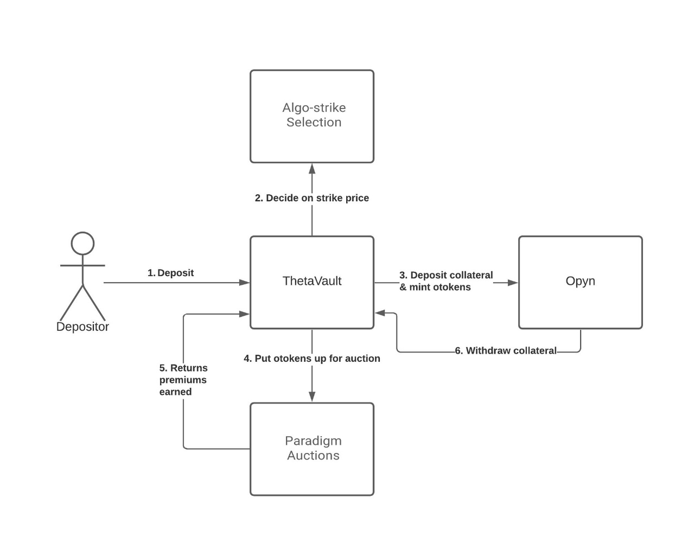

1. 1.

User deposits 100 ETH into T-ETH-C (ETH call).

1. 2.

On Friday 8 am UTC, the vault closes the previous week roound and subsequently uses 100% of its funds to mint 100 [otokens](https://opyn.gitbook.io/opyn/contracts/otoken), which are ERC20 representations of options contracts. The 100 ETH is locked for a week in Opyn.

1. 3.

After receiving the 100 otokens, the vault puts it up for auction on [Paradigm](https://docs.ribbon.finance/theta-vault/user-guides/how-to-participate-in-paradigm-auctions).

* + Registered users can participate and bid on the otokens. They pay the premiums for the otoken in ETH. Paradigm can use different kinds of auctions to maximise depositors' returns (e.g. [blind auctions](https://en.wikipedia.org/wiki/First-price_sealed-bid_auction))
  + At the end of the auction, the vault collects 1 ETH in premiums in the form of ETH.
  + Any remaining otokens that are not bought are burned, redeeming 1 otoken for 1 unit of collateral from Opyn.

1. 4.

On the next Friday 8 am UTC,

* + If the options expire in the money, the vault withdraws less than 100 ETH from Opyn.
  + If the options expire out the money, the vault withdraws exactly 100 ETH.

1. 5.

Let's say it expires out the money. The vault repeats step 2 with 101 ETH (original 100 ETH + 1 ETH premium).

### Codebase

|  |  |
| --- | --- |
| Name | Description |
| ​[libraries/Vault.sol](https://github.com/ribbon-finance/ribbon-v2/blob/master/contracts/libraries/Vault.sol)​ | Contains all data structures shared across all vault types |
| ​[libraries/VaultLifecycle.sol](https://github.com/ribbon-finance/ribbon-v2/blob/master/contracts/libraries/VaultLifecycle.sol)​ | Contains all logic related to how the Vault functions on a weekly basis |
| ​[vaults/BaseVaults/base/RibbonVault.sol](https://github.com/ribbon-finance/ribbon-v2/blob/master/contracts/vaults/BaseVaults/base/RibbonVault.sol)​ | Contains all common logic like accounting and options rolling shared across RibbonThetaVault and RibbonDeltaVault. |
| ​[vaults/BaseVaults/RibbonThetaVault.sol](https://github.com/ribbon-finance/ribbon-v2/blob/master/contracts/vaults/BaseVaults/RibbonThetaVault.sol)​ | Theta Vault contract that creates short options position with Opyn on a weekly basis |

## Deposit Flow

IMPORTANT: this is a technical explanation, if you need assistance on making a deposit please refer to [this page](https://docs.ribbon.finance/theta-vault/user-guides/how-to-deposit)!

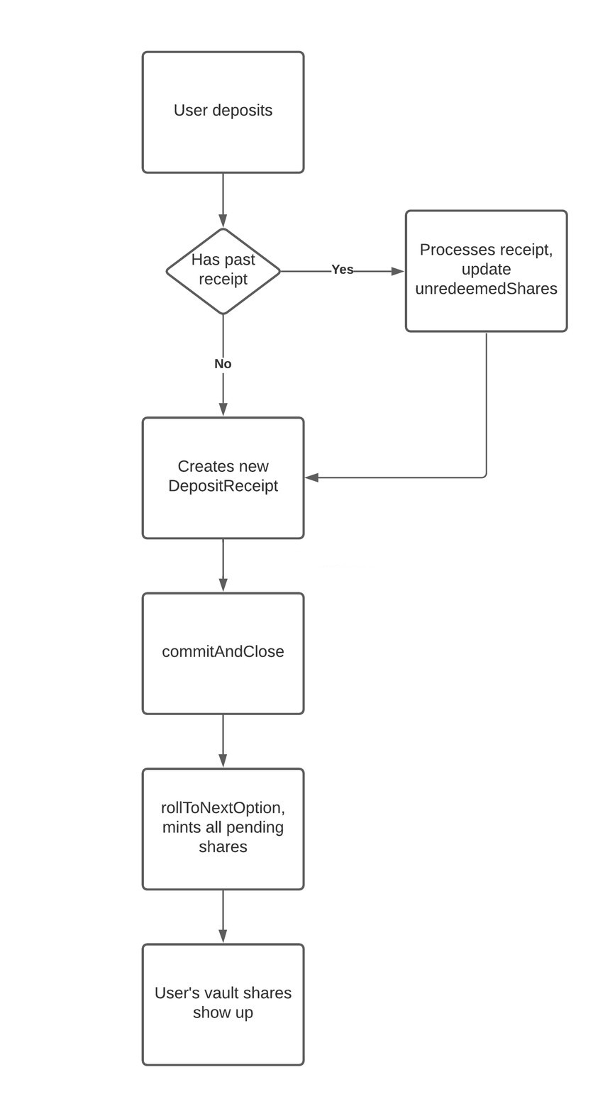

1. 1.

The user deposits 1 ETH into TV.

1. 2.

We first check if they have an existing DepositReceipt from the past round. Using the round and amount, we update the unredeemedShares field. This essentially tracks how many shares the user owns, but has not yet redeemed.

struct DepositReceipt {

round

amount

unredeemedShares

}

1. 1.

We create the DepositReceipt with the new details.

1. 2.

At rollToNextOption, the vault will mint all the shares that are owed to users to address(this). This increments the vaultState.round.

1. 3.

Since the round is concluded, the user's vault shares should show up by calling RibbonVault.shares(account)

The end result:

* Their shares show up automatically once the round concludes.
* DepositReceipts are used to track all the user's unredeemed shares. This is used for withdrawals and redemptions in the future.

## Withdrawal Flow

IMPORTANT: this is a technical explanation, if you need assistance on making a withdrawal please refer to [this page](https://docs.ribbon.finance/theta-vault/user-guides/how-to-withdraw)!

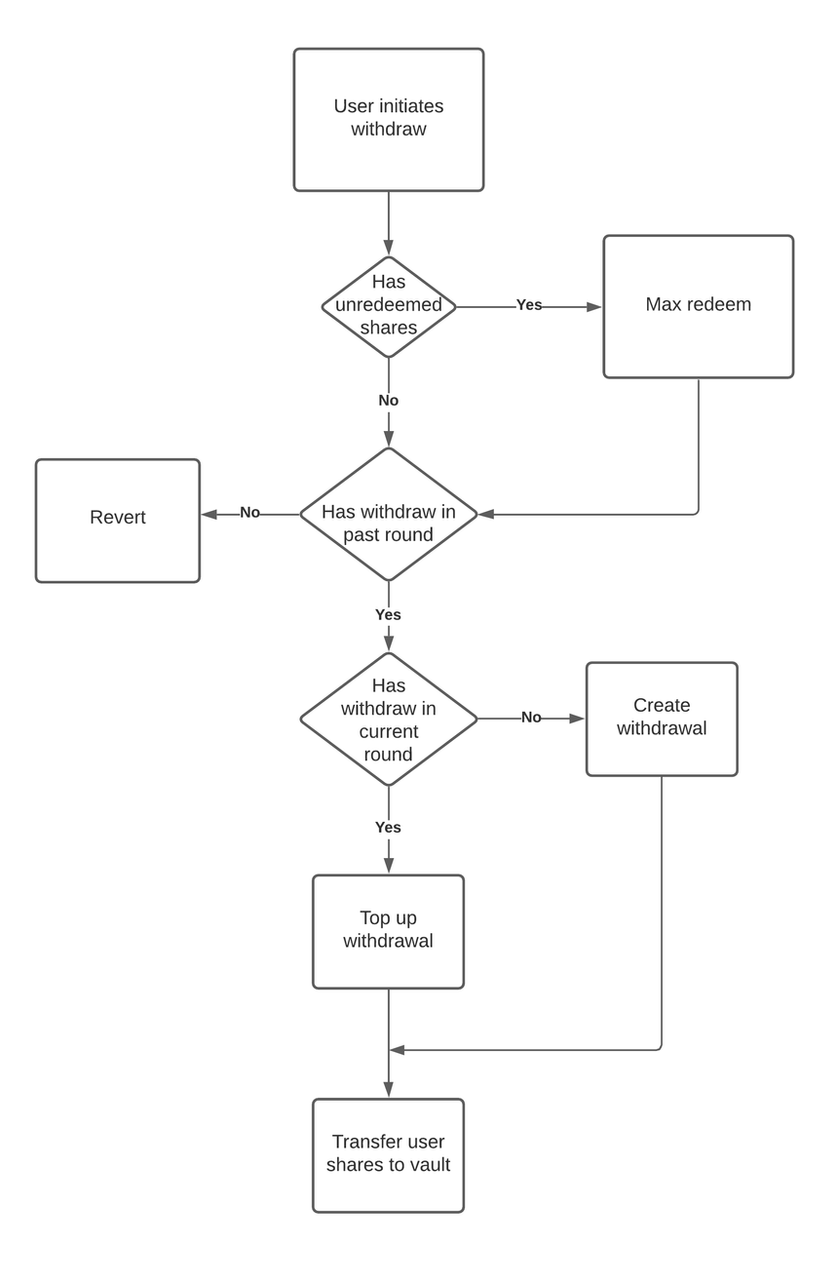

The withdrawal flow is slightly more involved. We have two types of withdrawals - Standard and Instant withdrawals.

### ****Standard withdrawals****

* Withdrawals are created with the initiateWithdraw function, which queues the shares to be burned.
* Withdrawals are completed with completeWithdraw function, which burns the shares, and returns the assets.
* Users can only call completeWithdraw only AFTER the week's Friday 10am UTC. For example, the user calls initiateWithdraw on Wednesday. They can only complete the withdrawal after the same week's Friday 10am UTC.
* Withdrawals stack on top of each other. This means that if I do initiateWithdraw(10), and I do initiateWithdraw(20) again, I will have a total withdrawal of 30 shares by Friday.

### ****Instant withdrawals****

* Instant withdrawals are only accessible to funds that are deposited mid-week.
* For example, user deposits 10 ETH into TV on Wednesday. They can call withdrawInstantly to return up to 10 ETH, from Wednesday till Friday.

## Share Redemption Flow

IMPORTANT: this is a technical explanation, if you need assistance on redeeming your vault shares please refer to [this page](https://docs.ribbon.finance/theta-vault/user-guides/how-to-transfer-vault-positions)!

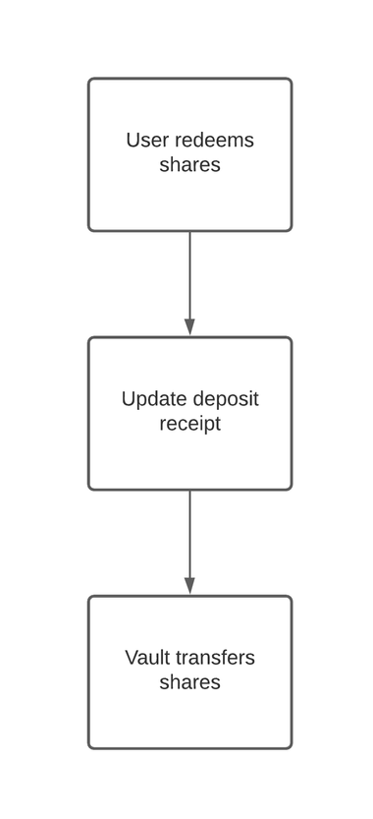

As mentioned before, when the user deposits into the vault, the vault mints and holds custody of the user's shares on address(this). This is not ideal for protocols or Meta-Vaults that want to hold custody of their shares. By calling the redeem or maxRedeem function, contracts are able to take custody of their vault shares.

The share redemption flow is also triggered implicitly when users call initiateWithdraw.

## Access Control

|  |  |
| --- | --- |
| Name | Privileges |
| Owner | The owner can set key parameters of the vault such as feeRecipient, performanceFee, managementFee, deposit cap etc.  Some functions in the vault's lifecycle is only limited to the owner, such as commitAndClose and rollToNextOption. |
| Admin | The admin can upgrade the proxy's implementation address. |

Both of these privileged roles use a Gnosis Safe multisig wallet.